***Science 5B***

***Unit 6: Conserving Earth’s Resources Sample Work***

***Option 2: Select information from text, books, and other reliable media about how a given human activity (e.g., in agriculture, industry, everyday life) affects Earth’s resources and environments.***

***by Shandilya Nookala***

The state of Minnesota contains diverse [**natural resources**](https://prodpcx-cdn-vegaviewer.emssvc.connexus.com/index.html?edgeauth=exp%3D1618261081~acl%3D%2F*~hmac%3Deece1d9e67f05e83a36d4a47bd4517b2d9f8e2b09e1c40f5e1412720b42f5782&playlist=b2JsLXBsYXlsaXN0cy84MjY4M2JjYS00MDNjLTRjNTAtODQ1MS04YWI5OThhNjBjZjguanNvbg==&glossary=Z2xvc3NhcnkvMzc3ODI0M2YtNmNkNS00Y2ZjLWIxMWEtNWVkNzJiYzAxY2MwLmpzb24=&globalanalyticsid=ff3028f2-d5c1-4cd0-a43a-089c3f694cf0&platformid=V2) such as forests, wind energy, minerals, and diverse wildlife. Natural resources are either renewable or non-renewable. [**Renewable resources**](https://prodpcx-cdn-vegaviewer.emssvc.connexus.com/index.html?edgeauth=exp%3D1618261081~acl%3D%2F*~hmac%3Deece1d9e67f05e83a36d4a47bd4517b2d9f8e2b09e1c40f5e1412720b42f5782&playlist=b2JsLXBsYXlsaXN0cy84MjY4M2JjYS00MDNjLTRjNTAtODQ1MS04YWI5OThhNjBjZjguanNvbg==&glossary=Z2xvc3NhcnkvMzc3ODI0M2YtNmNkNS00Y2ZjLWIxMWEtNWVkNzJiYzAxY2MwLmpzb24=&globalanalyticsid=ff3028f2-d5c1-4cd0-a43a-089c3f694cf0&platformid=V2)are replenished naturally faster than they are used by humans. [**Nonrenewable resources**](https://prodpcx-cdn-vegaviewer.emssvc.connexus.com/index.html?edgeauth=exp%3D1618261081~acl%3D%2F*~hmac%3Deece1d9e67f05e83a36d4a47bd4517b2d9f8e2b09e1c40f5e1412720b42f5782&playlist=b2JsLXBsYXlsaXN0cy84MjY4M2JjYS00MDNjLTRjNTAtODQ1MS04YWI5OThhNjBjZjguanNvbg==&glossary=Z2xvc3NhcnkvMzc3ODI0M2YtNmNkNS00Y2ZjLWIxMWEtNWVkNzJiYzAxY2MwLmpzb24=&globalanalyticsid=ff3028f2-d5c1-4cd0-a43a-089c3f694cf0&platformid=V2)are replenished very slowly or not at all. Humans use non-renewable resources faster than they can be replaced. Minnesota contains both renewable and non-renewable resources.

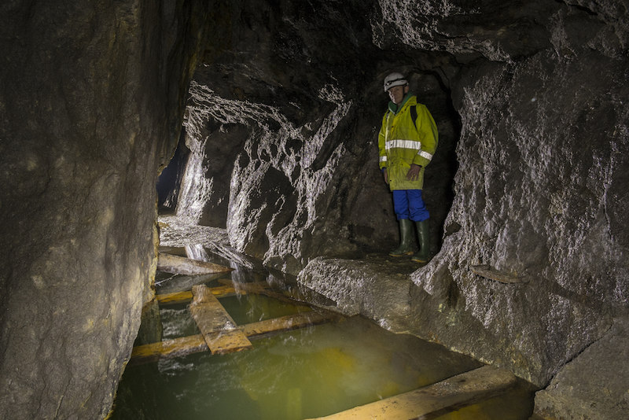

Rock Mine

Rocks, minerals, and metals are examples of nonrenewable resources. Rocks and mineral deposits are formed very slowly over many thousands of years or longer. This is too slow for these materials to be replaced in our lifetimes. Metals are not replaced at all. There is a finite amount of metal in Earth’s crust. Several minerals are mined from Minnesota, including iron ore, copper, nickel, platinum, and cobalt mineral deposits. These metals have a variety of uses, including construction and electronics. Granite, limestone, gravel, and sand are also mined in Minnesota. All of these materials are used for construction. Granite is also a common material for statues because it is not easily broken or worn away.

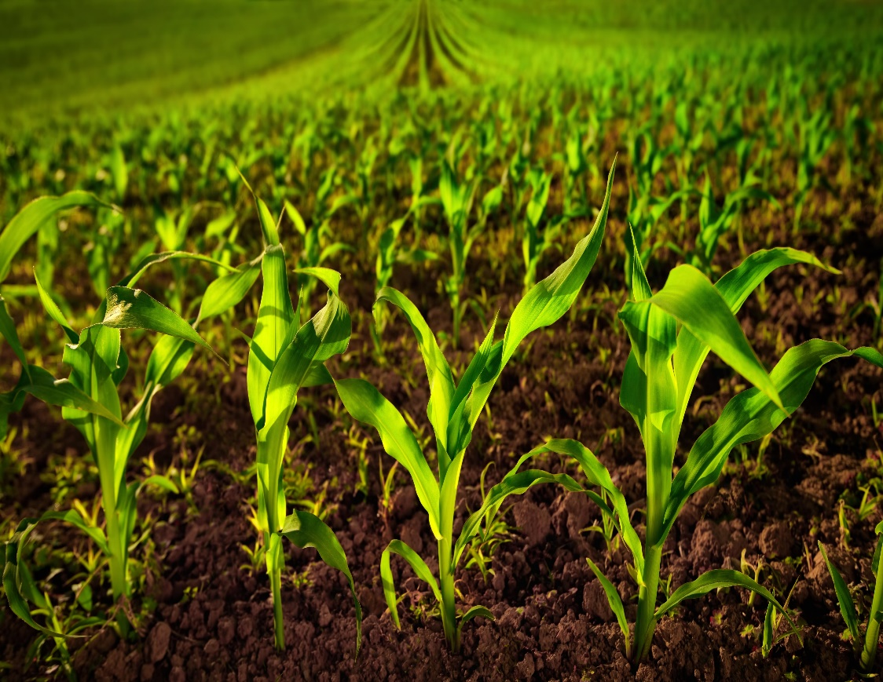

Crops Growing in Soil

Minnesota also contains very fertile soil. Farming is the largest industry in the state. This is due to the large areas of nutrient-rich soil. Soil is a nonrenewable resource. This is because soil can take hundreds to thousands of years to form. When soil loses its natural nutrients or is washed away by erosion, it cannot be replaced in our lifetimes.

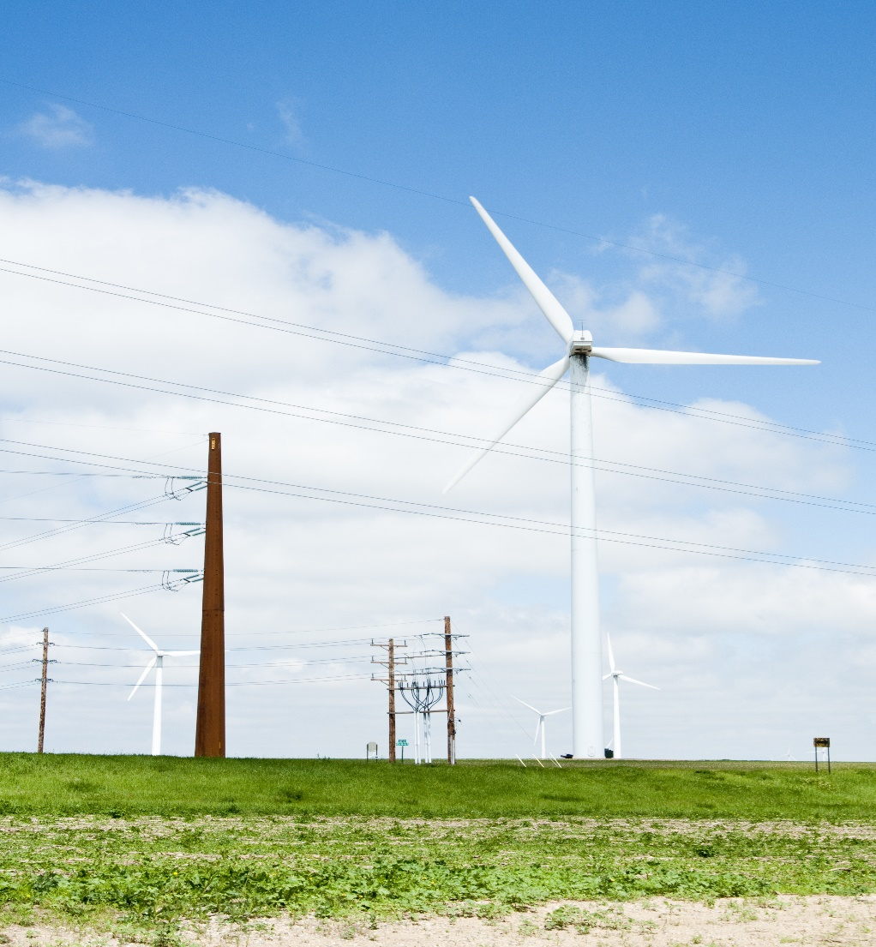

Wind Turbine

Renewable resources in Minnesota include water, timber, wildlife, and wind energy. Strong winds whip through the prairies of Minnesota, making it an ideal place to build wind turbines. These turbines harness energy from the wind to make electricity. This resource is renewable because wind cannot be used up.

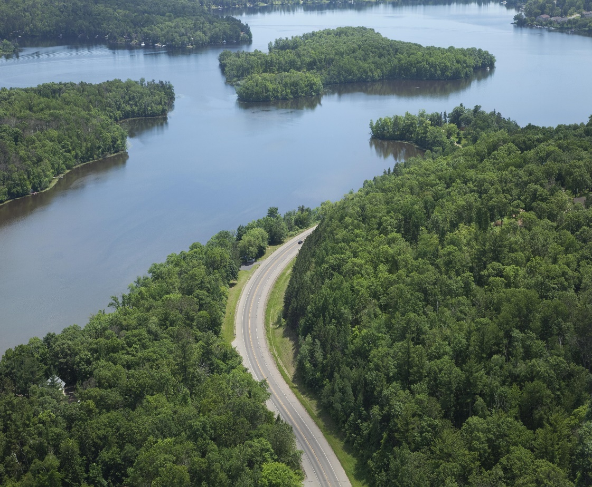

Forest Beside a River

Minnesota also contains large forests and many lakes, rivers, and streams. Fresh water is a valuable resource for people and wildlife. You need clean fresh water for drinking, farming, and cleaning. Water is renewable because it is naturally replenished by the water cycle. Forests are also a resource for people and wildlife. The forest is a valuable ecosystem that many organisms depend on. People use the wood from trees to build homes. And wood is burned for heat. Since trees are living things that grow back, they are renewable.

Resources like water and timber are only renewable if they can be replenished by natural systems faster than humans use them. Overuse of water dries up streams and aquifers faster than they can be refilled by rain or snow. Cutting down too many trees in one area removes them faster than they can regrow and destroys forest ecosystems. It is important to conserve these natural resources to make sure they are available in the future.

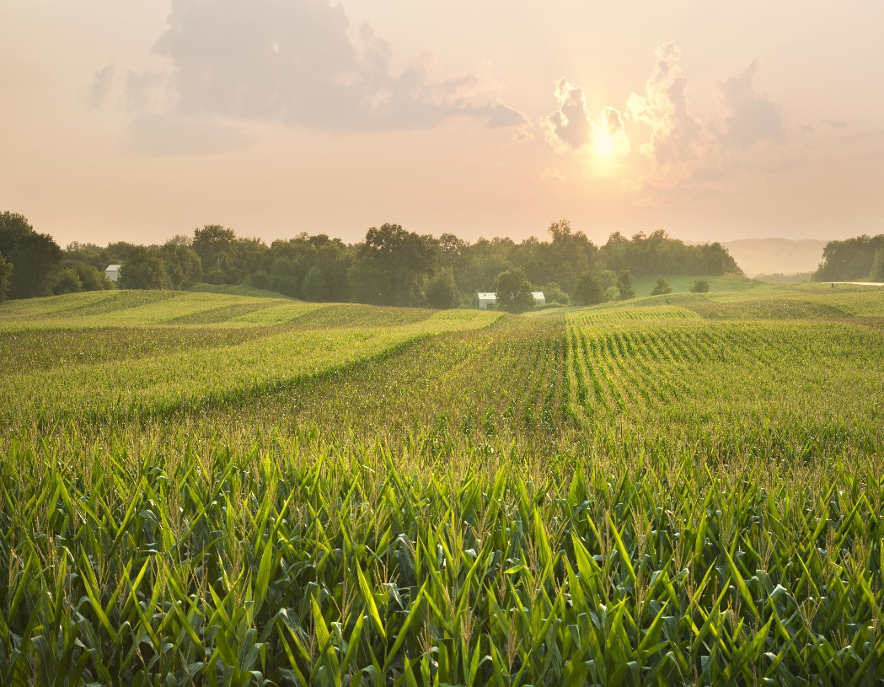

Field Filled with Crops

Throughout human history, people have been changing the environment around them for their own benefit. Some of these changes can also benefit other organisms on the planet. Examples of human changes to the environment can be seen in prairie ecosystems. Prairie soil is rich in nutrients that plants need to grow. This makes prairie lands ideal places for farming. Over half of Minnesota is covered by farmland. These farms are used to grow crops and to graze livestock. The majority of Minnesota’s farms are on land that was once prairie.

Agriculture is the largest industry in the state of Minnesota. This means farming provides the most jobs and money in the state. This makes farms an essential part of the state’s economy. Jobs and revenue from farms are necessary for both individuals and the community.

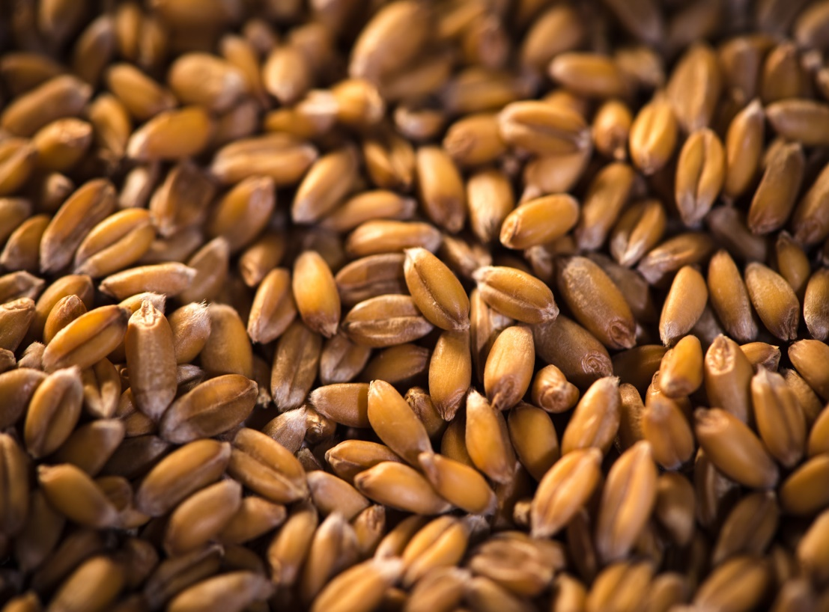

Image of Grain Grown in Minnesota

Minnesota’s farms also benefit people outside the state. People all over the United States eat food grown in Minnesota. Grains, vegetables, dairy, and meat raised in Minnesota help provide food for the whole country.

So much of the prairie in Minnesota has been changed to farmland and grazing land. This means that a lot of the natural prairie habitat has been lost. Native grasses have been cut down and removed to make space for crops. All of this has been good for humans. But these are generally changes for the worse for the prairie habitats themselves.

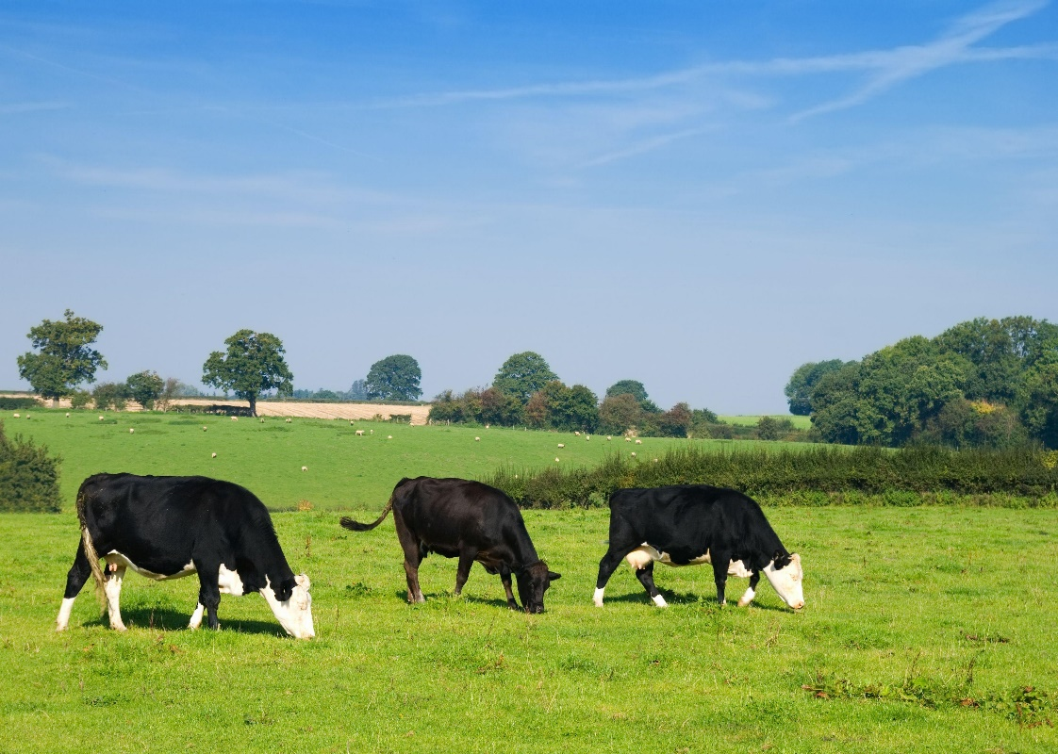

Responsible Grazing in Action

But some human activities can benefit the plants and animals in the prairie ecosystem. Responsible grazing, when it is practiced, is one example.

The responsible grazing process is as follows: Free-range cows, goats, chickens, and other livestock feed on the natural prairie grasses. Manure from livestock naturally fertilizes the soil. If animals are allowed to graze in one spot for too long, they will eat all the grass before it can grow back. This destroys the prairie soil. Responsible grazing means the animals are rotated to different areas. This allows time for grass to grow back.

Responsible grazing also leaves resources for wild animals. This means primary consumers can share the grazing land with livestock. Having more [**primary consumers**](https://prodpcx-cdn-vegaviewer.emssvc.connexus.com/index.html?edgeauth=exp%3D1618261081~acl%3D%2F*~hmac%3Deece1d9e67f05e83a36d4a47bd4517b2d9f8e2b09e1c40f5e1412720b42f5782&playlist=b2JsLXBsYXlsaXN0cy84MjY4M2JjYS00MDNjLTRjNTAtODQ1MS04YWI5OThhNjBjZjguanNvbg==&glossary=Z2xvc3NhcnkvMzc3ODI0M2YtNmNkNS00Y2ZjLWIxMWEtNWVkNzJiYzAxY2MwLmpzb24=&globalanalyticsid=ff3028f2-d5c1-4cd0-a43a-089c3f694cf0&platformid=V2) means food for [**predators**](https://prodpcx-cdn-vegaviewer.emssvc.connexus.com/index.html?edgeauth=exp%3D1618261081~acl%3D%2F*~hmac%3Deece1d9e67f05e83a36d4a47bd4517b2d9f8e2b09e1c40f5e1412720b42f5782&playlist=b2JsLXBsYXlsaXN0cy84MjY4M2JjYS00MDNjLTRjNTAtODQ1MS04YWI5OThhNjBjZjguanNvbg==&glossary=Z2xvc3NhcnkvMzc3ODI0M2YtNmNkNS00Y2ZjLWIxMWEtNWVkNzJiYzAxY2MwLmpzb24=&globalanalyticsid=ff3028f2-d5c1-4cd0-a43a-089c3f694cf0&platformid=V2). Responsible grazing is thus beneficial for other species.

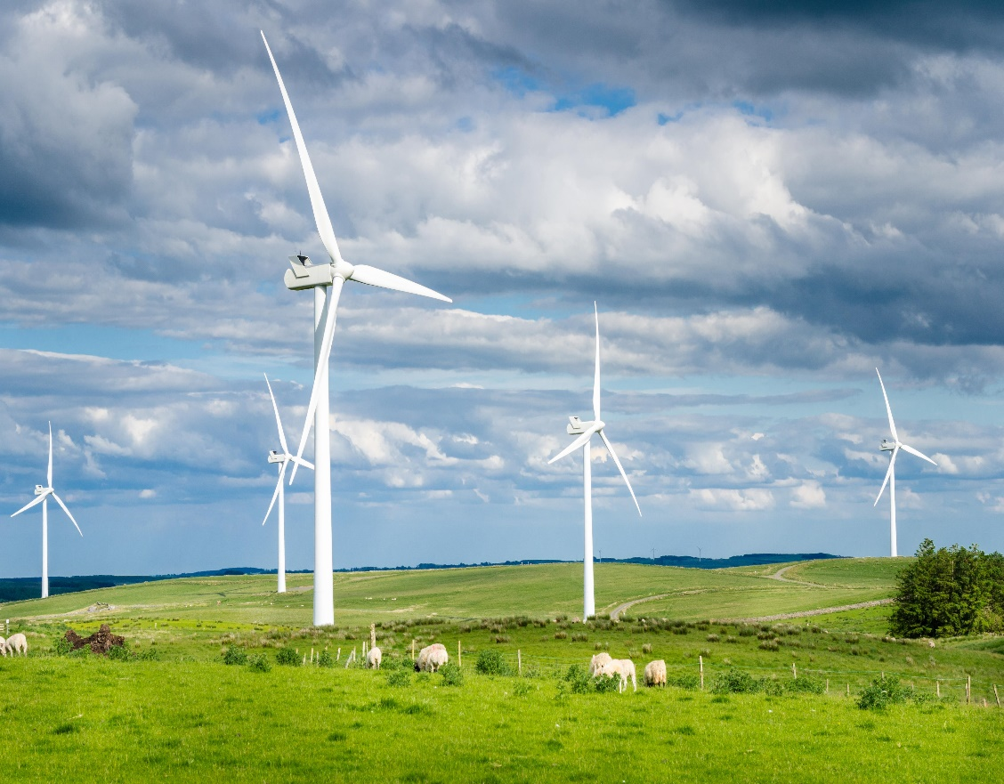

Wind Turbines in Open Field

Humans also change the prairie environment by building wind turbines. Wind turbines generate electricity from wind. The open landscape of prairies allows winds to build up speed. Without trees or mountains, strong winds can race across the open fields. This makes prairies great spots to harness wind energy. Wind energy is beneficial for humans because it is renewable. This means the planet will never run out of wind. Wind energy is also clean because it does not emit carbon into the atmosphere.

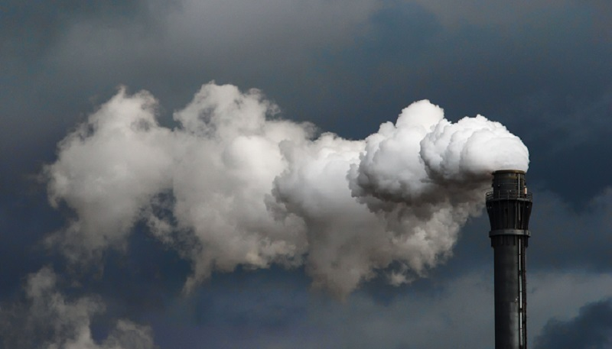

Factory Emitting Carbon Dioxide

Carbon emissions cause pollution and drive climate change. This is dangerous for all species on the planet. Thus, using clean energy benefits humans and other organisms.

The benefit to other organisms is somewhat limited. It is just less bad than if humans obtain energy by using fossil fuels. The animals and plants would be better off with no energy production at all!

Humans make changes to the environment to extract resources, build towns and cities, and make travel easier. These changes have immediate benefits for many people. However, sometimes the way humans change the environment is harmful to other organisms. The changes people make can also have unpredicted effects that are harmful to humans in the long term.

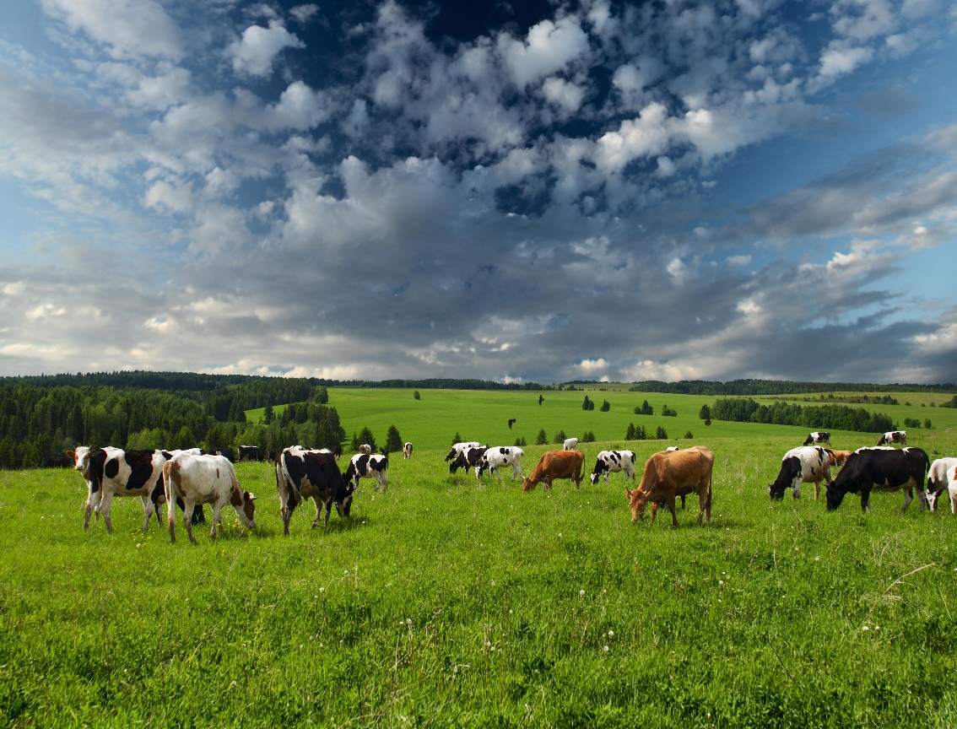

Cattle Grazing in the Prairie

The prairie grasslands of Minnesota once stretched across the western part of the state. Today, only 1 percent of the state’s prairies remain. This is in large part due to farming. The nutrient-rich soil of the prairie makes it an ideal place to plant crops. The crops planted where the prairies used to be are an important food source for people and livestock. You may remember about all the ways humans benefit from farming. However, farming is often harmful to other organisms.

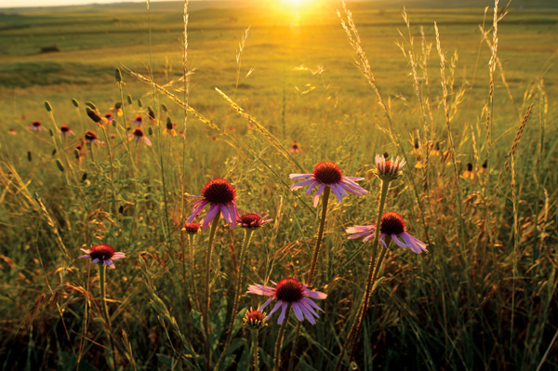

Grasses in the Prairie

The grasses of the prairie depend on nutrients in the soil to live. Native grasses also support the soil by supplying stability, structure, and other nutrients. When these grasses are cut down to make way for crops, the grass-soil relationship is broken. Over time, the soil loses nutrients because it is no longer supported by the grass. Farmers chose prairie lands because of the nutrient-rich soil. However, without grasses, the soil loses its natural nutrients.

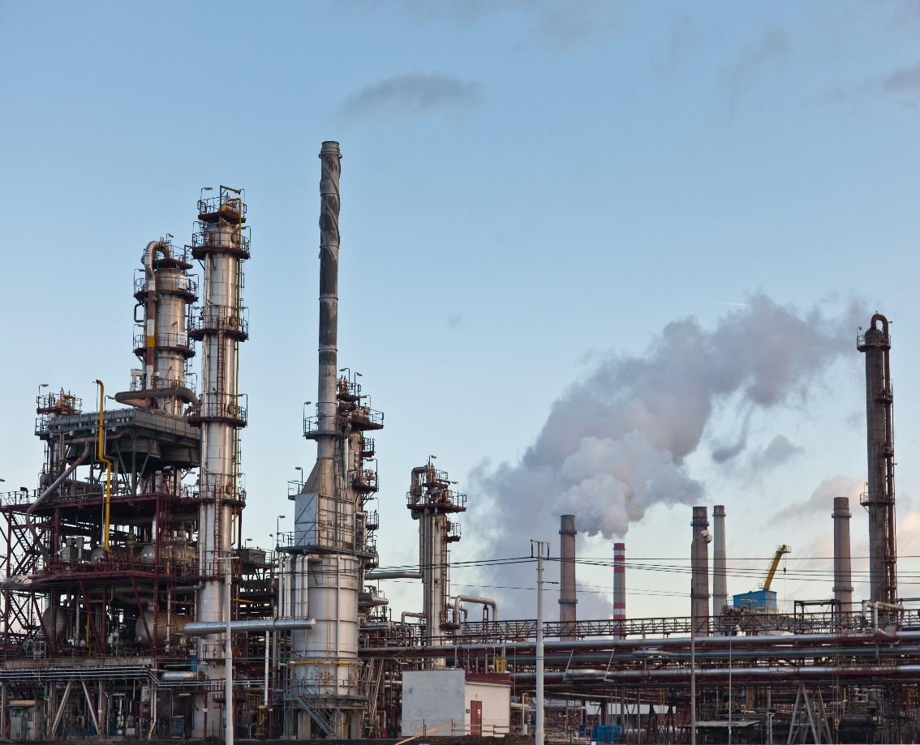

Fertilizer-manufacturing Factory

Eventually, farmers must use fertilizers to add nutrients back to the soil. Putting down fertilizer is time-consuming and costly. It weakens the soil in the long run. Factories that make fertilizers also cause air and water pollution. Pollution is harmful to both humans and other organisms.

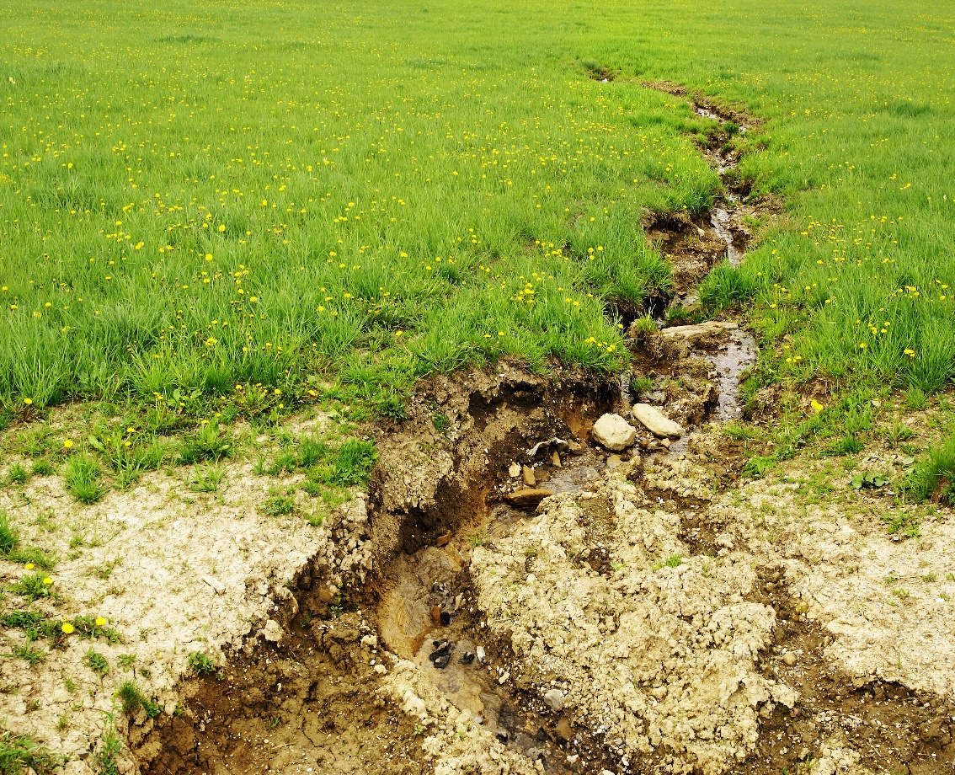

Soil Eroded Away

The roots of the prairie grasses also help to hold the soil together. Without grasses, prairie soil loses some of its structure. This can cause soil [**erosion**](https://prodpcx-cdn-vegaviewer.emssvc.connexus.com/index.html?edgeauth=exp%3D1618261081~acl%3D%2F*~hmac%3Deece1d9e67f05e83a36d4a47bd4517b2d9f8e2b09e1c40f5e1412720b42f5782&playlist=b2JsLXBsYXlsaXN0cy84MjY4M2JjYS00MDNjLTRjNTAtODQ1MS04YWI5OThhNjBjZjguanNvbg==&glossary=Z2xvc3NhcnkvMzc3ODI0M2YtNmNkNS00Y2ZjLWIxMWEtNWVkNzJiYzAxY2MwLmpzb24=&globalanalyticsid=ff3028f2-d5c1-4cd0-a43a-089c3f694cf0&platformid=V2). This means the soil is more easily worn away by water, wind, and other natural processes. Erosion also makes land harder to farm. This is bad for people who depend on farms for work and food.

When grasses are cut down for farms, the prairie[**food chain**](https://prodpcx-cdn-vegaviewer.emssvc.connexus.com/index.html?edgeauth=exp%3D1618261081~acl%3D%2F*~hmac%3Deece1d9e67f05e83a36d4a47bd4517b2d9f8e2b09e1c40f5e1412720b42f5782&playlist=b2JsLXBsYXlsaXN0cy84MjY4M2JjYS00MDNjLTRjNTAtODQ1MS04YWI5OThhNjBjZjguanNvbg==&glossary=Z2xvc3NhcnkvMzc3ODI0M2YtNmNkNS00Y2ZjLWIxMWEtNWVkNzJiYzAxY2MwLmpzb24=&globalanalyticsid=ff3028f2-d5c1-4cd0-a43a-089c3f694cf0&platformid=V2) losses its producers. This has ripple effects up to the [**primary consumers**](https://prodpcx-cdn-vegaviewer.emssvc.connexus.com/index.html?edgeauth=exp%3D1618261081~acl%3D%2F*~hmac%3Deece1d9e67f05e83a36d4a47bd4517b2d9f8e2b09e1c40f5e1412720b42f5782&playlist=b2JsLXBsYXlsaXN0cy84MjY4M2JjYS00MDNjLTRjNTAtODQ1MS04YWI5OThhNjBjZjguanNvbg==&glossary=Z2xvc3NhcnkvMzc3ODI0M2YtNmNkNS00Y2ZjLWIxMWEtNWVkNzJiYzAxY2MwLmpzb24=&globalanalyticsid=ff3028f2-d5c1-4cd0-a43a-089c3f694cf0&platformid=V2) and [**predators**](https://prodpcx-cdn-vegaviewer.emssvc.connexus.com/index.html?edgeauth=exp%3D1618261081~acl%3D%2F*~hmac%3Deece1d9e67f05e83a36d4a47bd4517b2d9f8e2b09e1c40f5e1412720b42f5782&playlist=b2JsLXBsYXlsaXN0cy84MjY4M2JjYS00MDNjLTRjNTAtODQ1MS04YWI5OThhNjBjZjguanNvbg==&glossary=Z2xvc3NhcnkvMzc3ODI0M2YtNmNkNS00Y2ZjLWIxMWEtNWVkNzJiYzAxY2MwLmpzb24=&globalanalyticsid=ff3028f2-d5c1-4cd0-a43a-089c3f694cf0&platformid=V2) of the ecosystem. Farming also physically displaces animals. By putting up fields and fences, native animals are pushed out of the land.

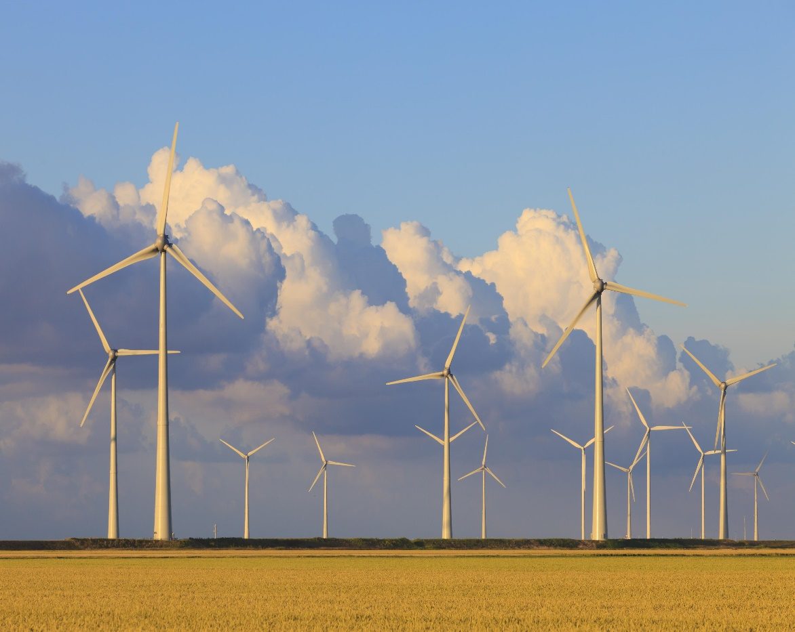

Wind Turbines Stretched Across the Land

Humans also change the prairie environment by putting up wind turbines. Wind turbines have many benefits for humans and other organisms. Wind energy is clean and, thus, does not contribute to climate change. However, wind turbines are large structures that disrupt the flat landscape. Scientists have found that some prairie animals leave areas that contain turbines.

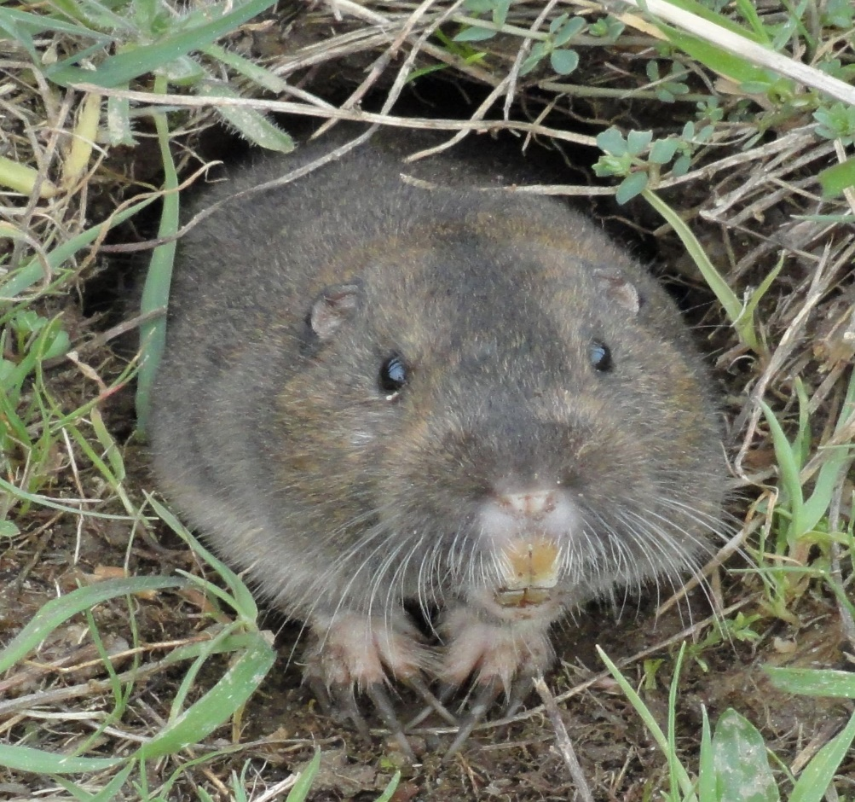

Gophers, One of the Animals Driven Away by Turbines

This happens even when people are careful not to disturb animal dens or nests. It is thought that the animals mistake shade from the turbines for shade from trees. To the animals, it’s as if a forest has grown around them overnight! The animals leave the shaded areas to find open prairies that they are adapted to. The noise from the turbines might also drive them away.

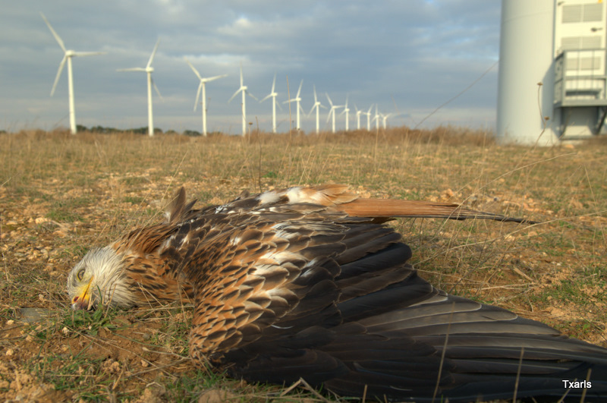

Bald Eagle Killed by Wind Turbine

Some wind farms have been built in the middle of important migratory routes. These are paths that birds take as they migrate north and south during the seasons. These birds are not adapted to having tall structures in this path and are confused by the rotating turbines. This leads to collisions that kill the birds.

Wind turbines change the environment in ways that are harmful to humans as well. People who live near wind farms can hear the constant noise of the turbines. The turbines also disrupt views of natural landscapes. Building turbines too close to homes or businesses can also be dangerous if the turbines were to become damaged and fall.